**ST. PAUL’S UNIVERSITY**



**School of communication and computer studies**

**FUNERAL MANAGEMENT SYSTEM**

**BY**

**TOM OUKO OKUDO**

**BSCNRB480122**

**Department of computer science**

*A research project submitted in partial fulfilment for the requirement of the award of a bachelor’s degree in computer science, Department of Computer Science, St. Paul’s University.*

**APRIL 2024**

DECLARATION

I do hereby declare without any reasonable doubt that the work presented is my own original and independent work and it has not been presented before to the faculty of science for the award of Bachelor of Science in Computer Science at ST. Paul’s University. No part of this report shall therefore be duplicated without my prior consent.

NAME ……………………………………REG NO……………………………

SIGNATURE ……………………………… DATE …………………………….

SUPERVISOR

NAME: MR. SAMUEL KARUGA

HOD Computer Science Department, St Paul’s University.

Sign…………………………….

ABSTRACT

The funeral management system plays a crucial role in the funeral industry by streamlining operations, enhancing customer service, and ensuring efficient management of funeral services. This abstract delves into the key aspects of funeral management systems based on the provided sources.

Funeral management systems offer a comprehensive solution for funeral homes to manage various aspects of their operations efficiently. These systems provide features such as scheduling, inventory management, record-keeping, billing, invoicing, customer relationship management, and funeral planning tools.  By utilizing advanced reporting features and customer relationship management, funeral homes can streamline their business services and sales effectivel.

The primary objective of an FMS is to facilitate efficient management of funeral arrangements, from initial client contact to post-service follow-ups. Features typically include comprehensive client information management, automated documentation generation (such as contracts and permits), inventory tracking (including caskets, urns, and flowers), scheduling and coordination of services, and accounting integration for streamlined financial management.

Funeral Management System is an indispensable tool for modern funeral homes seeking to enhance service delivery, optimize internal processes, and adapt to evolving industry demands. Its implementation represents a strategic investment towards achieving operational excellence, regulatory compliance, and sustained growth within the funeral service sector. Future research and development in FMS technology promise further innovations to meet the dynamic needs of funeral directors and their clientele.

**INTRODUCTION**

This project is aimed at developing a funeral management system that is important to any family or person in the world. Dealing with the death of a loved one can be particularly difficult, the F.M.S (Funeral Management System) is a system that can be accessed by everyone. Families can plan arrangements collaboratively with your funeral directors or entirely by themselves in the comfort of their home. It allows owners and managers to schedule funerals and communicate with customers.

**PROBLEM STATEMENT**

In many societies, the process of managing funeral arrangements is often burdened with inefficiencies, lack of organization, and emotional distress for the bereaved families. The current manual and traditional methods employed in funeral management present several challenges that hinder a smooth and respectful experience during this difficult time.

With the rising of people’s living standards, the traditional [funeral services](https://www.dissertationtopic.net/doc/503185) can’t meet people’s higher demand. As a part of modern services, the modern funeral services would reform the traditional service model and will be merged with advanced ideas. Using advanced computer and network information management technology can realize civilized, humanized, and personalized funeral services. Meeting people’s growing demand of culture from multi-level, multi-positions and multi-projects is the development mainstream direction of funeral services.

**Objectives**

Therefore, there is a need to develop a functional and efficient funeral management system that can address these challenges and improve the overall customer experience. Objectives include the following.

1. To develop a website that allows customers to view products and services, check their payments.
2. To provide customers from far-flung areas with access to the funeral services.
3. Improving efficiency and providing better services to clients using advanced reporting features, calendar planning, and workload estimation.
4. To automate the funeral management system to reduce manual transactions and improve efficiency.
5. To reduce burnout for funeral service providers by streamlining the management process.
6. To improve customer satisfaction by providing a seamless online experience
7. Effective communication is crucial in the funeral industry, where timely and sensitive communication with grieving families is essential. FMS provides tools for managing communication channels, including email, SMS, and online portals, allowing funeral homes to keep families informed about arrangements, updates, and other important information. This helps build trust and rapport with clients and ensures that families feel supported throughout the funeral process.
8. FMS aims to improve financial management by providing tools for budgeting, expense tracking, and financial reporting.

**Time frame/ project schedule**

The below table shows the time allocation in weeks.

|  |  |  |
| --- | --- | --- |
| **Phase** | **Task to be performed** | **Duration in weeks** |
| A | Data collection | 3 |
| B | Data analysis | 2 |
| C | Design specification | 1 |
| D | System/Database design | 2 |
| E | Coding | 3 |
| F | Documentation | 3 |

**Budget**

|  |  |  |  |
| --- | --- | --- | --- |
| **ITEM** | **QUANTITY** | **UNIT COST (ksh.)** | **TOTAL** |
| Transparent paper | 1rim | 700 | 700 |
| Embossed paper | 1rim | 600 | 600 |
| Ruler | 3 | 50 | 150 |
| Photocopy paper | 3rims | 500 | 1500 |
| Biro pens | 3 | 50 | 100 |
| Flash disk | 1 | 1200 | 1200 |
| **TOTAL** |  |  | **4250** |

|  |  |
| --- | --- |
| **Other expenses** | **Amount (ksh.)** |
| Laptop | 80,000 |
| Traveling | 3,000 |
| Printing& typing | 3,000 |
| Lunch | 5,000 |
| Miscellaneous | 3,000 |
| TOTAL | 94,000 |
| **GRAND TOTAL** | **98250** |

**Risks of funeral management system**

* Data Security and Privacy Concerns: Funeral management systems often contain sensitive personal and financial information about deceased individuals and their families. There's a risk of data breaches, unauthorized access, or misuse of this information, leading to privacy violations and potential legal consequences.
* System Downtime and Technical Issues: Dependence on technology means that funeral management systems are vulnerable to technical glitches, system failures, or downtime. Any disruption in system availability can impact funeral arrangements, service delivery, and customer satisfaction.
* Training and Adoption Challenges: Introducing a new funeral management system requires training staff members to use the system effectively. Resistance to change, lack of training, or difficulties in system adoption can hinder the successful implementation and utilization of the system.
* Integration with Existing Systems: Funeral homes may already have existing systems or processes in place for managing operations. Integrating a new funeral management system with these existing systems can be complex and may require customization or interoperability challenges.
* Regulatory Compliance: Funeral homes are subject to various regulations and legal requirements governing the funeral industry. The funeral management system must comply with these regulations, such as record-keeping requirements, consumer protection laws, and health and safety standards.
* Customer Service and Communication: Overreliance on automated processes within the funeral management system may lead to a lack of personalization and diminished customer service. Effective communication with bereaved families is crucial, and any breakdown in communication can lead to dissatisfaction and reputational damage.
* Cost Overruns and Budget Constraints: Implementing a funeral management system involves initial investment costs for software, hardware, training, and ongoing maintenance. There's a risk of cost overruns, especially if implementation timelines are extended or if additional customization or upgrades are required.
* Dependency on Vendors: Funeral homes rely on software vendors or service providers for the development, maintenance, and support of the funeral management system. Dependence on external vendors can pose risks related to vendor stability, support responsiveness, and contractual obligations.
* Scalability and Flexibility: As funeral homes grow or change, their needs for the funeral management system may evolve. The system must be scalable and flexible enough to accommodate changing requirements, additional functionalities, or expansions to multiple locations.
* Cultural Sensitivity and Ethical Considerations: Funeral management systems must be culturally sensitive and respectful of diverse funeral customs, traditions, and religious practices. Failure to address cultural sensitivities or ethical considerations can lead to misunderstandings, offense, or negative perceptions within communities served by the funeral home.

Addressing these risks requires careful planning, robust cybersecurity measures, ongoing monitoring, and proactive risk management strategies to ensure the successful implementation and operation of the funeral management system while mitigating potential adverse impacts on operations, reputation, and service delivery.

**Functional requirements**

Functional requirements refer to the features and capabilities that a funeral management system must have to fulfill its intended purpose.

* Funeral Logistics Management: Services that assist in picking up the deceased person for cremation or burial, preparing the body, and transporting it to the cemetery.
* Inventory Management: Tracking inventory beyond stock levels, such as coffins, caskets, urns, chapels, cremators, or meeting rooms. It is crucial to have an up-to-date snapshot of inventory for quick decision-making.
* Records Management Solution: A system that seamlessly integrates with all aspects of the business, including booking systems and mapping, while ensuring compliance and basic reporting functionality.
* Financial Management: Process payments, invoices, and receipts for funeral services and merchandise. Calculate costs, fees, taxes, and discounts accurately. Generate financial reports, statements, and summaries for accounting purposes.
* Communication and Collaboration: Facilitate communication between funeral home staff, clients, vendors, and external stakeholders. Support email notifications, appointment reminders, and event invitations. Enable collaboration on service planning, document sharing, and task assignments.
* User Administration and Security: Administer user accounts, roles, and permissions. Implement access controls, authentication mechanisms, and data encryption. Monitor system activity, audit logs, and security incidents.
* Client Management: Capture and maintain client information, including contact details, family members, and preferences. Record and track client interactions, communications, and service requests. Manage client contracts, agreements, and payment information.
* Deceased Management: Record and manage information about deceased individuals, including personal details, next of kin. Track the status and location of remains, including burial or cremation arrangements. Generate permits, and other required documentation.
* Service Planning and Scheduling: Schedule and coordinate funeral services, viewings, and ceremonies. Manage availability of facilities, staff, vehicles, and equipment for services. Plan logistics such as transportation, catering, and floral arrangements

By incorporating these essential functional requirements are essential for a comprehensive funeral management system that streamlines operations, enhances client service, ensures regulatory compliance, and supports the efficient management.

**Non-Functional requirements**

Non-functional requirements refer to the performance and quality characteristics of the funeral management system.

* System availability: The system should be available and accessible to users when they need it.
* System response time: The system should respond quickly to user requests and actions.
* Scalability: The system should be able to handle a large volume of users and operational requests.
* Security: The system should be secure and protect sensitive data.
* Usability: The system should be user-friendly and easy to navigate for both clients and managers.
* Affordability: The system should be affordable, with pricing that is suitable for small or large businesses.
* Maintainability: Modifiability: The system should be easy to modify, extend, or customize to accommodate changing business requirements, regulations, or user needs.
* Documentation: The system should be well-documented, including technical specifications, user manuals, and training materials, to facilitate system maintenance and support.

**1. Use case diagram for Funeral management system**

Use case diagrams, which show the interactions between a system and its environment. It shows the various actors (users, roles) and the use cases (actions, features) they perform. In the case of a funeral management system, the actors could be manager, administrator, and customers.

ADMIN

MANAGER

CUSTOMER

**2.Class diagram for funeral management sysytem**

It shows the structure of the system, including the classes (objects), their attributes, and their relationships. It includes classes such as Funeral, Customer, Employee, and Inventory, along with their attributes and methods. The Funeral System class acts as a controller or manager for the system, providing functionalities to add, remove, and manage funerals, customers, employees, and inventory items.

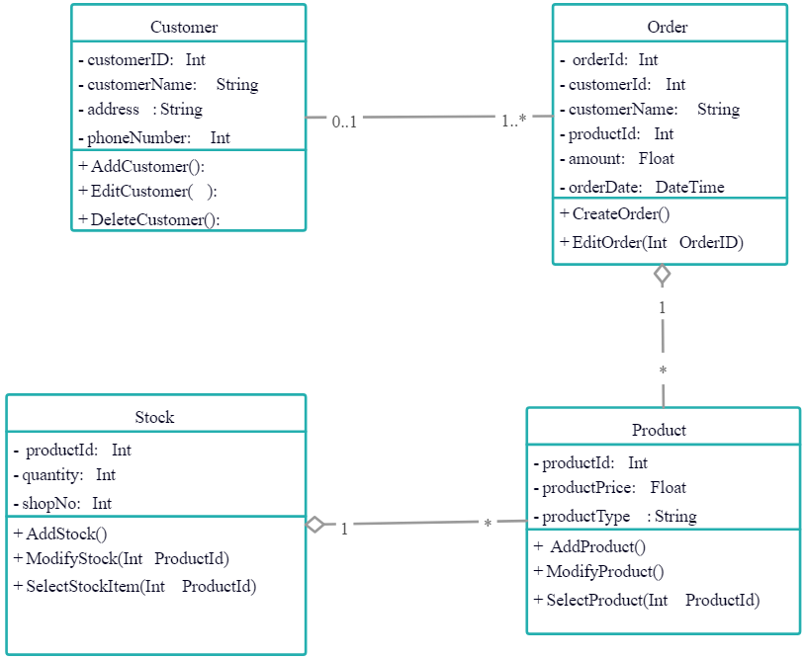

**3.Activity diagram for funeral management system**

It shows the flow of activities (tasks, processes) within a system. In a funeral management system, an activity diagram could be used to show the steps involved in funeral management system. The process starts with initiating the funeral process and progresses through various stages such as collecting customer information, scheduling the funeral service, assigning a funeral director, arranging logistics, managing payments, conducting the funeral service, and finally, finalizing the process.

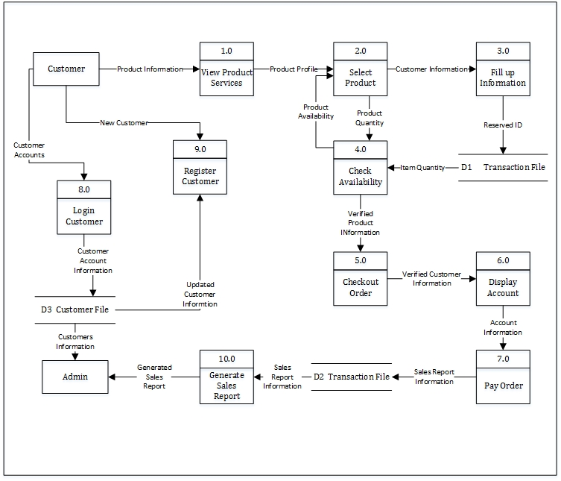

**4.State machine diagram for funeral management system**

It represents the various states that an object or system can be in, as well as the transitions between those states, specifying the sequence of events that an object goes through during its lifetime in response to events.

start

Log in to the funeral management system

Collect customer information

Schedule funeral service

Conduct funeral service

Check the payments

Arrange funeral service

Manages schedules

Manage arrangements

Manage the services

Manage payments

Log out from the system

stop

**Designing the User Interface**

While designing the user interface, I have tried to make the interfaces as user-friendly as possible so that from the interface the users easily understand what they are doing and what they should do. Moreover, I have attached quick tips in all the buttons so that they can understand what will happen if they Click it.

Below are diagrams to showcase user interfaces of the funeral management system and the wire frame diagram.

|  |  |  |  |
| --- | --- | --- | --- |
| WELCOME TO FUNERAL MANAGENENT SYSTEM  WE INSPIRE - WE ADVISE - WE DESIGN - WE DELIVER  CUSTOMER LOGIN   |  | | --- | |  |       ID NO.   |  | | --- | |  |   SIGN IN.   |  | | --- | |  | |

FUNERAL MANAGEMENT

**MUSLIM**

**CHRISTIAN**

**products**

**Administrative matters**

**Obituary writing.**

**Harse.**

**Cascate .**

**Cloths.**

**Tents.**

**Chairs .**

**P. A system.**

**Catering .**

**Hired mourners .**

**Methodology**:

The purpose of this chapter is to present system flows and techniques applied in this study. The proponents followed the standard software development life cycle (SDLC), to show and present the solutions to the problems identified, using incremental waterfall model.

The development process is the series of activities the guides the development software. A software development process model is broken down into different activities. Basic activities of software engineering processes are as follows: Planning, Analysis, Design, Development, Testing, Implementation, and Maintenance phases.

To realize the successful completion of this project I intend to carry out feasibility study on the current system to compare with the intended system which will help in designing of a new system.

**Planning Phase**

The purpose of the planning phase is to identify the problem create solutions and translate it to system functionality requirements. In this phase, the researchers are involved in creating a set of plans to that guides the development of the system.

The project started with the identification of the companies which may accept the groups offer for a systematic study of the development. After that, the group initially conducted interviews and surveys of the identified companies here in and outside Bacolod. Their automation needs more than determined. Choosing from among the interested companies was there made with reference to their assessed willing to provide data and entertain process related queries. Villacrusis funeral services were selected by the researcher-proponents.

**Analysis Phase**

In this phase, the researcher-proponents processed data and information that were collected and gathered from the company. To validate the result, another interview and observation were conducted. During this time, a final listing of the desired needs wit report to process is determined.

**Design Phase**

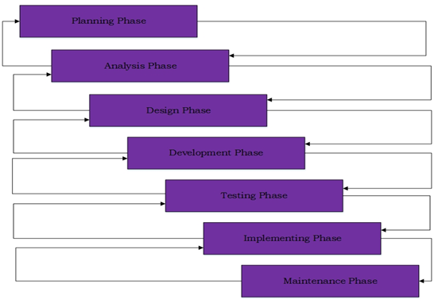

**Incremental Waterfall Model**

System design includes the decisions on the organization of the system into subsystems, the subsystems to hardware and software components and major conceptual and policy decisions that form the framework for detailed design.

In this phase, software requirement specification (SRS) is the reference of the system architects to come up with the best architecture or design for the system.

After analyzing all the data and information gathered it is now ready for a database program. The proponents by them were able to plan the interfaces and begin with its design.

**Development Phase**

The information to analysed and initial design is forwarded to this phase, create which is the working part of the system through coding, and create databases, hardware construction, and overall system development.

After coding and development, the system is being tested and checked for any errors. Especially the administrator and the customer accounts are run for this purpose.

**Data collection analysis presentation**

The tools I intend to collect data are questionnaires, interviews, and observation. The purpose for collecting data is to understand the current system and the new system being developed and its user requirements.

Questionnaires

Questionnaires refer to forms filled by respondents alone. They can be handed out or sent by mail and later collected. A questionnaire requires respondents to fill the form themselves and require high level of literacy. Where multiple languages are common, questionnaires should be prepared using the major language of the target group.

Observation

This technique involves researcher making observations. Observation is usually flexible and do not necessarily need to be structured around a hypothesis.

Interviews

An interview is used to obtain information from one person about information, problems, or topic. The interview will help the researcher establish a rapport (a close and harmonious relationship) with respondent.

After data has been collected, analyzing them will be the next task. The analysis of data requires several closely related operations such as establishment of categories. The data collection techniques will provide sufficient information for the study.

1. Conduct a survey to gather data on the current state of the funeral management system and identify areas for improvement.
2. Develop a conceptual framework for the proposed funeral management system.
3. Design and develop the website and automate the funeral management system.
4. Test the system with a sample group of customers and funeral service providers to gather feedback and make necessary adjustments.
5. Implement the system and monitor its performance to ensure that it meets the objectives.

Expected Outcomes:

1. Improved efficiency in the funeral management system.
2. Increased customer satisfaction due to a seamless online experience.
3. Reduced burnout for funeral service providers.
4. Increased accessibility to funeral services for customers in remote areas.
5. Improved overall performance of the funeral management system.

**Requirement Specifications**

**Operational Feasibility**

The goals of this system study are to develop the following functionalities:

1. An online web-based and mobile application that can be accessed anywhere through an internet connection.
2. Provide an organized system which allows the company to monitor their income.
3. Generate monthly and yearly sales reports.
4. View products and services of the companies.

**Program Environment**

**Front End**

CSS or Cascading Style Sheets was first developed in 1997 as a way for web developers to define the look and feel of their web pages. It was intended to allow developers to separate content from design so that HTML could perform more of the function that it was originally based on the markup of content, without worry about the design and layout. This programming language will be responsible for placing the data being uploaded to the website in their proper places.

Bootstrap is the most popular HTML, CSS, and JS framework for developing responsive, mobile first projects on the web. Bootstrapping usually refers to the starting of a self-sustaining process that is supposed to proceed without external input.

HTML or HyperText Markup Language is the standard markup language used to create web pages. XHTML or Extensible HyperText Markup Language is a family of XML markup languages that mirror or extend versions of the widely used HTML, the language in which Web pages are written. These are the programming languages that are going to be used for the development of the front end of the system.

**Back End**

PHP is a server-side scripting language designed for web development but also used as a general-purpose programming language. PHP code can be simply mixed with. HTML code or it can be used in combination with various emplacing engines and web frameworks. The PHP code is usually processed by a PHP interpreter, which is usually implemented as a web server native module or Common Gateway Interface (CGI) executable.

MySQL is the most popular database system used with PHP. MySQL is a database system used on the web. It is a database system that runs on a server. It is ideal for both small and large applications. MySQL is very fast, reliable, and easy to use. It supports standard SQL. It compiles on a number of platforms; it is also free to download and use. MySQL is developed, distributed, and supported by Oracle Corporation.

**Technical Feasibility**

Hardware specification (maximum requirement)

Client

* Dual-Core Processor
* 1 GB Ram
* 256 Video Card
* Android 4.2 version up to latest version

Server

* Quad Core Processor
* 4GB Ram (Internal Memory)
* 500GB Hard Drive
* 4GB Video Card

Software specifications (maximum requirement)

Client

* Google Chrome Version 6.3.2
* Mozilla Firefox 17.6
* Windows XP Operating System

Server

* Parallels B Plesk management software
* XAMPP

**System Architecture**

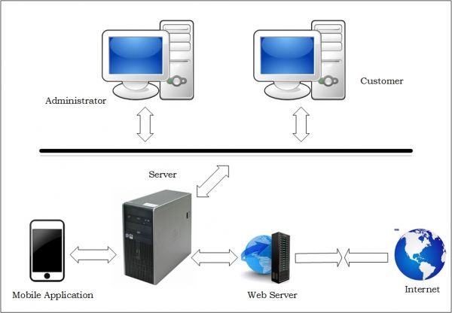

**Testing phase**

This stage or phase refers to the testing stage of the system where defects are identified, reported, fired and retested, until if achieves the quality standard required.The following are the test procedure that are used in testing the software to ensure that it meets the users’ requirements:

Unit testing

It is testing where individual components or units of code are tested in isolation, usually by a developer.

The purpose of unit testing is to verify that each individual unit of code is working correctly and producing the expected output.

Functional testing

Is a type of testing where the entire system or application is tested to ensure that it meets the functional requirements specified by the stakeholders. Functional testing is typically performed by a quality assurance (QA) team, and it may involve manual or automated testing. The purpose of functional testing is to verify that the system or application is working correctly from an end-user perspective.

Unit testing focuses on testing individual units of code, while functional testing focuses on testing the overall functionality of the system or application. Both types of testing are important in software development.

**Training phase**

The key to effective training on a leave management system is to ensure that the trainees understand the system's purpose and functionality, feel comfortable using it, and have the ongoing support they need to use it effectively.

Here are some general guidelines that may be helpful: -

1. System security: Emphasize the importance of keeping the system secure, including protecting login credentials, and avoiding sharing sensitive information.
2. Provide hands-on practice: Once you have demonstrated how to use the system, provide hands-on practice for the trainees. This will allow them to get comfortable with the system and ask any questions they may have.
3. Provide a high-level overview of the leave management system. Explain what it is used for, who will be using it, and how it will benefit the organization.
4. Demonstrate how to use the system. Cover tasks such as requesting time off, checking leave balances, and approving or denying leave requests.
5. After the training, I will provide ongoing support to the trainees as they begin to use the system. This may include answering questions, troubleshooting issues, and providing additional training as needed.

**Quality of the funeral management system**

The advancement in technology in the last few decades has improved our lives in every aspect. Manually driven systems are being substituted by the computerized systems. The existing system is totally manual. The quality of a funeral management system (FMS) is crucial in ensuring that funeral homes and directors can effectively and efficiently manage all aspects of funeral arrangements and services.

The quality of this project is to formulate a sensible analysis of the current system, a system which will: -

* Enhance data security by employing system measures that restricts unauthorized access. This will be achieved by use of passwords such that only an individual will be allowed to view his/her leave portal.
* Reduce the amount of paperwork required for any service.
* The system will be intuitive and easy to use, with clear navigation and straightforward processes.
* The quality of a funeral management system (FMS) is crucial in ensuring that funeral homes and directors can effectively and efficiently manage all aspects of funeral arrangements and services. Here are key aspects that contribute to the quality of an FMS:
* Comprehensive Features: A high-quality FMS should offer a comprehensive range of features to manage various aspects of funeral services. This includes tools for managing client information, tracking funeral arrangements, managing legal paperwork, managing inventory (e.g., caskets, urns), scheduling services, and processing payments.
* User-Friendly Interface: The system should have an intuitive and user-friendly interface that is easy to navigate and use. Funeral directors and staff should be able to quickly access information, update records, and perform tasks without unnecessary complexity or training.
* Reliability and Stability: A reliable FMS should operate smoothly without frequent downtime or technical issues. It should be able to handle a large volume of data efficiently and be accessible whenever needed, especially during critical times like funeral services.
* The quality of a funeral management system (FMS) is crucial in ensuring that funeral homes and directors can effectively and efficiently manage all aspects of funeral arrangements and services. Here are key aspects that contribute to the quality of an FMS:
* Comprehensive Features: A high-quality FMS should offer a comprehensive range of features to manage various aspects of funeral services. This includes tools for managing client information, tracking funeral arrangements, handling legal paperwork, managing inventory (e.g., caskets, urns), scheduling services, and processing payments.
* User-Friendly Interface: The system should have an intuitive and user-friendly interface that is easy to navigate and use. Funeral directors and staff should be able to quickly access information, update records, and perform tasks without unnecessary complexity or training.
* Reliability and Stability: A reliable FMS should operate smoothly without frequent downtime or technical issues. It should be able to handle a large volume of data efficiently and be accessible whenever needed, especially during critical times like funeral services.

**Maintenance procedure of the funeral management system**

The system requires maintenance and support. In this phase, comments and suggestions made by the customers and administrators of the system are considered for its enhancement. For this purpose, maintenance of the system is scheduled every five months in order to maintain system’s functionality and its updating.Maintenance of a funeral management system is critical to ensure that it continues to function properly and meets the needs of the organization. Regular updates, backups, performance tuning, user support, security maintenance, and documentation are all essential components of an effective maintenance procedure.

* Regular updates to the funeral management system are essential to ensure that it remains secure, bug-free, and compatible with other systems.
* Regular backups of the system data are important to ensure that no data is lost in case of system failures or other issues. The backup process should be automated and include all data related to the system.
* Offering ongoing support to users, including troubleshooting issues, answering questions, and providing training on new features.
* Security maintenance is essential to ensure that the leave management system remains secure. This may include regular security audits, monitoring for unauthorized access, and implementing security patches and updates.
* It is important to maintain up-to-date documentation of the funearal management system, including system architecture, user manuals, and troubleshooting guides. This documentation can be helpful in training new users and troubleshooting issues.

**Management strategies after system implementation/ future improvement**

* This System will be able to send text messages to customers reminding them on their application.
* The system will also be able to include other religion i.e. Muslims and Hindus.

**1. User Adoption and Optimization:**

Training and Support: Provide comprehensive training for staff on all aspects of the FMS. Offer ongoing support through resources, knowledge bases, or refresher courses to ensure proficiency.

Data Entry and Quality Control: Establish clear protocols for data entry to ensure accuracy and consistency. Implement quality control measures to verify data integrity.

Process Optimization: Regularly analyse data from the FMS to identify bottlenecks or areas for improvement. Streamline workflows and automate repetitive tasks to improve efficiency.

**2. Communication and Customer Experience:**

Family Portal Integration: Consider integrating the FMS with a family portal, allowing families secure access to obituaries, service details, and communication with your staff.

Personalized Communication: Utilize the FMS data to personalize communication with families. Generate customized pre-arrangement guides or send automated reminders based on their needs.

Feedback Mechanisms: Develop mechanisms to collect feedback from families on their experience using the FMS. Use this feedback to improve both the system and the overall service experience.

**3. Data Analytics and Reporting:**

Performance Measurement: Utilize the FMS data to track key performance indicators (KPIs) like case volume, revenue, customer satisfaction, and resource utilization.

Data-Driven Decision Making: Leverage data analysis to inform strategic decisions regarding staffing, service offerings, or pricing structures.

Regulatory Compliance: Use the FMS to generate reports for regulatory compliance purposes, ensuring you meet all legal requirements.

**4. Future-Proofing your FMS:**

Technology Integration: Explore integrating the FMS with other relevant solutions, like accounting software, online payment gateways, or grief counselling resources.

Mobile Accessibility: Consider offering a mobile app or web portal for staff to access the FMS remotely, improving flexibility and responsiveness.

Emerging Technologies: Stay informed about emerging technologies like AI chatbots or virtual reality tours, which could potentially enhance the service experience.

**5. Ongoing Improvement:**

Vendor Relationship: Maintain a strong relationship with your FMS vendor for ongoing support, software updates, and access to their expertise.

User Feedback: Encourage open communication and actively seek feedback from staff on the FMS functionality and user experience.

Regular Reviews: Conduct periodic reviews of the FMS to assess its effectiveness and identify opportunities for further development.

**REFERENCE**

1. <https://www.softwareadvice.com/funeral-home/>
2. <https://gather.app/blog/funeral-management-system/>
3. <https://selectfunerals.com/79/Select-Quality-Management-System.html>
4. <https://www.ey.com/en_us/strategy-transactions/the-shift-to-intelligent-facilities-management>
5. <https://www.geeksforgeeks.org/software-development-life-cycle-sdlc/>
6. <https://miro.com/diagramming/what-is-a-uml-diagram/>
7. <https://www.apm.org.uk/resources/what-is-project-management/>
8. <https://www.altexsoft.com/blog/functional-and-non-functional-requirements-specification-and-types/>
9. <https://www.interviewbit.com/blog/system-architecture/>
10. <https://www.globallegalpost.com/news/planning-for-system-upgrades-and-future-improvement-phases-1311896976>